1. Open an anaconda prompt window
2. Navigate to the folder on your machine where the application file (e.g. app.py) is located. If using Windows, for example, cd documents/Wine_Quality_Rating_Group_5
3. Type set FLASK_APP=app.py and hit enter.
4. Type flask run and hit enter. You should get a response that tells you where the application is running. For example: * Serving Flask app "app"

* Running on http://127.0.0.1:5000/ (Press CTRL+C to quit)

1. Open any browser and please enter the URL http://127.0.0.1:5000/
2. A web form is displayed to enter the chemical properties of the wine, something like this 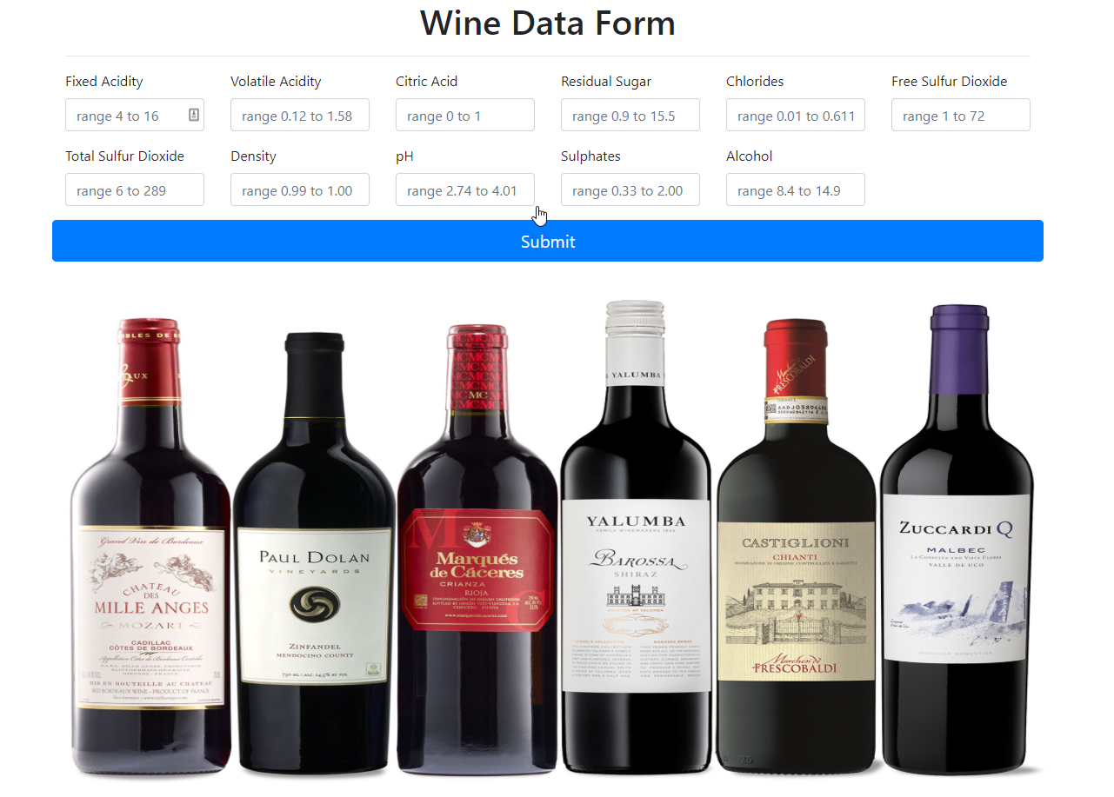
3. Please enter all the fields within the range and click submit to determine the quality of wine.

Here are some sample data to try out

Sample 1

**fixed acidity**

6.2

**volatile acidity**

0.39

**citric acid**

0.43

**residual sugar**

2

**chlorides**

0.071

**free sulfur dioxide**

14

**total sulfur dioxide**

24

**density**

0.99428

**pH**

3.45

**sulphates**

0.87

**alcohol**

11.2

Sample 2

**fixed acidity**

9.4

**volatile acidity**

0.3

**citric acid**

0.56

**residual sugar**

2.8

**chlorides**

0.08

**free sulfur dioxide**

6

**total sulfur dioxide**

17

**density**

0.9964

**pH**

3.15

**sulphates**

0.92

**alcohol**

11.7